**Lina Sachuk**

Aurora, CO, 80016

Phone: (303)525-1188 | Email: sachuklina@gmail.com

LinkedIn: <https://www.linkedin.com/in/lina-sachuk-346938103/>

GitHub: <https://github.com/LinaSachuk>

**Summary**

Motivated and results-driven Data Analyst professional with ability to identify business needs and develop valuable solutions to drive accuracy and process efficiency. Strong communication, analytical, and problem-solving skills. Trilingual in English, Russian, and Ukrainian. Enthusiastic and eager to contribute to team success through hard work, attention to detail and excellent organizational skills. Motivated to learn, grow and excel in Data Science.

**Technical Skills**

**Tools:** Microsoft Excel, MS Office, Web Development, Python, Flask, Pandas, Jupyter Notebook, JavaScript, HTML/CSS, Tableau, Machine Learning, Deep Learning, API Integration, Data Visualization Tools, Data collection and Analysis

**Databases:** SQL, MySQL, PostgreSQL, Non-relational Databases

**Projects**



**ETL Project - The Best 50 Superhero Movies of All Type**

| **Link to GitHub** <https://github.com/LinaSachuk/SuperHeroes-ETL>

**| Link to Deployed Project**  <https://super-heroes.herokuapp.com/>

* ETL (extract, transform, load) used to blend data from multiple sources.

Data Analysis and Visualization with different tools.

* My own project
* Tools include Python, Flask, API, HTML/CSS, Jupyter Notebook, Pandas, Plotly, PostgreSQL, Heroku



**Nobel Prize Winners - Data Visualization Project**

| **Link to GitHub** <https://github.com/LinaSachuk/NobelData>

**| Link to Deployed Project** <https://linasachuk.github.io/NobelData/>

* Nobel Prize Winners Data Visualization with different tools.
* My own project
* Tools include Python Flask–powered RESTful API, Selenium WebDriver, HTML/CSS, JavaScript, D3, amCharts, SweetAlert, Anime.js and MongoDB cloud database

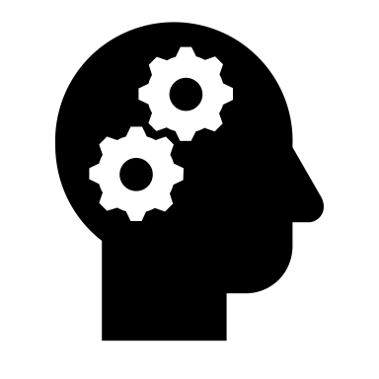

**Art and ML – Machine Learning Project**

| **Link to GitHub** <https://github.com/LinaSachuk/Art-and-ML>

**| Link to Deployed Project** <https://art-and-ml.herokuapp.com/>

* The project idea is build on my Old Love for the Great Art and my New Love for Machine Learning. Flask App with an Image Recognition Model.
* My own project
* Tools include Python, Flask, Selenium WebDriver, HTML/CSS, MongoDB cloud database, Jupyter Notebook, Pandas, Plotly, Heroku, TensorFlow, Tableau, Deep Learning

**Experience**

**Implementation Consultant** 2016 – 2019

**FAST ENTERPRISES** Denver, CO

Spearheaded full spectrum of the system implementation project by working in close collaborating with all project stakeholders. Held concurrent responsibility for analyzing user requirements, liaising with systems partners, validating designs, troubleshooting glitches, documenting issues and finding, and communicating to management.

*Key Accomplishments:*

* Served as a subject matter expert for performing post-production analysis to validate outcomes of enhancement projects.

**Land Surveyor Assistant, Engineering Intern** 2006 – 2013

**GEOCENTER** Zhytomyr, Ukraine

Used theodolites, transits, levels and satellite-based global positioning systems to determine longitudes and latitudes of important features and boundaries in survey areas

*Key Accomplishments:*

* Computed geodetic measurements and interpreted survey data to determine positions, shapes and elevations of geomorphic and topographic features

**Education**

1. **Data Analytics:** University of Denver, Denver, CO

A 24-week intensive program focused on gaining technical programming skills in Excel, VBA, Python, R, JavaScript, SQL Databases, Tableau, Big Data, and Machine Learning.

1. **Full Stack Web-Development**: Galvanize, Denver, CO

### A 24-week intensive program focused on Full Stack Web-Development fundamentals

1. **M.S. Computer Science, Automatics & Control**:Polytechnic State University, Zhytomyr, Ukraine

### A 5 years program focused on Computer Science and Engineering fundamentals